**SELF DEFENSE SYSTEM WITH GSM SOS MESSAGE ALERT**

THIS MINI PROJECT WORK IS SUBMITTED IN PARTIAL FULFILLMENT

OF THE REQUIREMENT FOR THE DEGREE OF

**BACHELOR OF TECHNOLOGY**

IN

**ELECTRONICS & COMMUNICATION ENGINEERING**

SUBMITTED BY

|  |  |
| --- | --- |
| **Name** | **Univ. Roll No.** |
| PAPRI RUDRA | 10800319069 |
| ROHIT KUMAR JASHWARA | 10800319070 |
| SHREYOSHI MISHRA | 10800319071 |
|  |  |
|  |  |

UNDER THE GUIDANCE OF

**Dr. Rupam Das**

Assistant Professor



DEPARTMENT OF ECE

**ASANSOL ENGINEERING COLLEGE**

AFFILIATED TO

MAULANA ABUL KALAM AZAD UNIVERSITY OF TECHNOLOGY

May 2022

|  |  |
| --- | --- |
|  | **DEPARTMENT OF ECE** |
| **ASANSOL ENGINEERING COLLEGE**  Vivekananda Sarani, Kanyapur, Asansol, West Bengal – 713305 |

*Certificate of Recommendation*

I hereby recommend that the preliminary thesis report entitled, **”SELF DEFENSE SYSTEM WITH GSM SOS MESSEGE ALERT”** carried out under my supervision by the group of students listed below may be accepted in partial fulfilment of the requirement for the degree of “Bachelor of Technology in ECE Engineering” of Asansol Engineering College under MAKAUT.

|  |  |
| --- | --- |
| **Name** | **Univ. Roll No.** |
| PAPRI RUDRA | 10800319069 |
| ROHIT KUMAR JASHWARA | 10800319070 |
| SHREYOSHI MISHRA | 10800319071 |
|  |  |
|  |  |

Countersigned:

………………………………

(Dr. Rupam Das)

Mini Project Supervisor

Dept. of ECE,

Asansol Engineering College,

Asansol-713305

………………………………

(Prof (Dr) Arunava De)

HOD, ECE

Asansol Engineering College,

Asansol-713305

|  |  |
| --- | --- |
|  | **DEPARTMENT OF ECE** |
| **ASANSOL ENGINEERING COLLEGE**  Vivekananda Sarani, Kanyapur, Asansol, West Bengal – 713305 |

***Certificate of Approval***

The forgoing mini project document is hereby approved as creditable study of an engineering subject carried out and presented in a manner satisfactory to warrant its acceptance as prerequisite to the degree for which it has been submitted. It is understood that by this approval the undersigned does not necessarily endorse or approve any statement made, opinion expressed or conclusion drawn therein but approve the thesis only for the purpose for which it is submitted.

…………………………………

(Dr. Rupam Das)

Mini Project Supervisor

…………………………………

(Manas Kumar Datta)

Mini Project Supervisor

|  |  |
| --- | --- |
|  | **DEPARTMENT OF ECE** |
| **ASANSOL ENGINEERING COLLEGE**  Vivekananda Sarani, Kanyapur, Asansol, West Bengal – 713305 |

***ACKNOWLEDGEMENT***

It is my great privilege to express my profound and sincere gratitude to our Mini Project Supervisor, Dr.Rupam Das and Manas Kumar Dutta for providing me a very cooperative and precious guidance at every stage of the present project work being carried out under his supervision. His valuable advice and instructions in carrying out the present study has been a very rewarding and pleasurable experience that has greatly benefited me throughout the course of work. We would like to convey my sincere gratitude towards Prof (Dr) Arunava De, Head of the Department of Electronics and Communication, Asansol Engineering College for providing us the requisite support for time completion of our work. We would also like pay my heartiest thanks and gratitude to all the teachers of the Department of Electronics and Communication, Asansol Engineering College for various suggestions being provided in attaining success in our work. I would like to express my earnest thanks to my other colleagues along with all technical staffs of the Department of Electronics and Communication, Asansol Engineering College for their valuable assistance being provided during my project work.

………………………………… (Papri Rudra)

.………………………………… (Rohit Kr. Jashwara)

………………………………… (Shreyoshi Mishra)

***ABSTRACT***

Here, we design a stun gun circuit using a 555 Timer to produce a current fluctuating signal and a voltage multiplier using a transformer and a multiple stage arrangement of voltage doublers using capacitors and diodes. The stun gun circuit is based on the principle behind a conventional stun gun. A 555 Timer is used to produce an oscillating signal of frequency determined by the external passive elements connected to the Timer. These low current electric pulses are fed to a step-up transformer to produce a high volt signal, which is further increased by a voltage multiplier circuit. The voltage multiplier circuit consists of multiple stages of voltage doubler each consisting of two diodes and two capacitors. The voltage doubler circuits are based on Villard doubler method. Output voltage is directly proportional to the number of stages.

|  |  |  |
| --- | --- | --- |
|  | ***CONTENT*** | **Page No.** |
| 1. | MOTIVATION | 6 |
| 2. | DESIGN METHODOLOGY AND WORKING | 7 |
| 3. | COMPONENTS REQUIRED | 8-15 |
| 4. | FLOW CHART | 16 |
| 5. | CIRCUIT DIAGRAM | 17-18 |
| 6. | HARDWARE IMPLEMENTATION | 19 |
| 7. | CIRCUIT DESCRIPTION | 20-21 |
| 8. | RESULT | 22 |
| 9. | LIMITATIONS | 23 |
| 10. | CONCLUSION | 24 |
| 11. | FUTURE SCOPE | 25 |
| 12. | REFERENCE | 26 |

1. **MOTIVATION**

* ***ETHICAL MOTIVATION: -***
* In 2019 a total of 4977 children below the age of 18 were sexually assaulted in India. Among them 26% of the girls were in capable of basic self-defenses.
* The 2019 crime records national crime record bureau reports shows a 7.3% increase crime against women.
* Although India’s largest self-defense program is yet to be accessible to all the girl in the country. The NSDC urges every community to inculcate self-defense practices among their girls
* ***TECHNICAL MOTIVATION: -***
* Although various technology is present for woman safety none often real time defense and alert message transmission simultaneously.
* Be it a Taser or a stun gun there is a 15% chance that it may not immobile the assaulter, but the SOS message is successfully sent.
* Thus, a product using existing microcontroller technology incorporated with the GSM connectivity would enhance the utilities of these devices as a must have for women

1. **DESIGN METHODOLOGY & WORKING**

The working of our project Self Defense System with SOS GSM Message Alert is described below:

As soon as the switch is pressed the operation of 555 timer starts, which produces a pulsating electric signal of low current, which is then passed to NPN transistor which turns on and off allowing an alternating current to pass through it. After which it passed through the Step-Up. Transformer which steps-up the low current produced earlier to a voltage of around 30v. Then a no. of voltage doublers is used to double the voltage produced by the transformer which is then connected to the output of the stun gun. The additional security that our project provide is that if ever our user fails to aim at the correct target point, the switch of the stun gun pressed sends a signal to the GSM which is used to send emergency alert message to the prefaded emergency numbers.

1. **COMPONENTS USED**

The components required for the development of the project are as follows:

ELECTRONIC CIRCUIT: -

* 9v Battey
* LM555CM-555 Timer
* 750 ohms
* variable resistance
* 10uF-10pc
* 0.1uf-2pc
* step-up Transformer- 1:11 IRF220
* NPN Darlington transistor-Schottky Diode--10pc
* Switch

MESSEGE ALERT: -

* GSM module
* Arduino uno

LM555CM-555 Timer

The 555 timer works by using three 5 kΩ resistors to divide the supply voltage in three. Two comparators compare these voltages to the input voltage, then sets or resets a flip-flop accordingly.

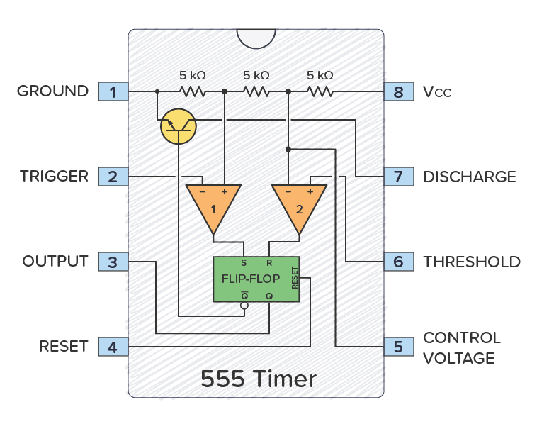

Fig. 1: LM555CM-555 Timer

At the top of the diagram above, you have three 5 kΩ transistors between VCC and GND.

These resistors divide the VCC voltage in three. Below the resistors, there are two triangles. These are comparators. If the comparator input marked with + has a higher voltage than the one marked with −, the output is high; otherwise, the output is low.

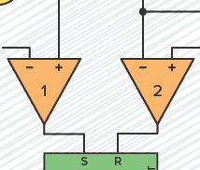

Fig 2: Comparators inside the 555 Timer

The 5k resistors set fixed voltages for each of the comparators: one-third of the VCC voltage goes to the positive (+) input of comparator 1, and two-thirds of the VCC voltage goes to the negative (–) input of comparator 2.

The green box is an SR Flip-Flop. It is a simple memory device with two states: output high (flip) and output low (flop).

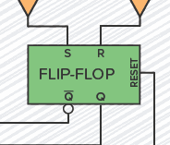

Fig 3: SR Flip-flop inside the 555 Timer

It has two inputs, set (S) and reset (R). **S** sets the output (Q) to high and **R** resets it to low.

Q is always the opposite of Q.

Comparator 1 checks if the voltage on the **Trigger pin** is below 1/3 of VCC. If it is, it sets the flip-flop so that the **Output pin** becomes high.

Comparator 2 checks if the voltage on the **Threshold pin** is above 2/3 of VCC. If it is, it resets the flip-flop so that the **Output pin** becomes low.

The flip-flop also controls a transistor that connects the **Discharge pin** to ground when the output is low.

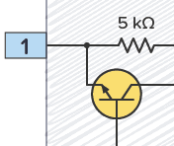

Fig 4: Transistor inside 555 Timer

## SUMMARY

The pins responsible for making the **Output (pin 3)** go high or low are the **Trigger (pin 2)** and the **Threshold (pin 6)**.

The Trigger pin is responsible for setting the output high. When the voltage on the trigger pin goes lower than one-third of VCC, comparator 1 outputs high and sets the flip-flop high, which in turn sets the Output pin high.

Pin 6 is labeled Threshold; when its voltage exceeds two-thirds of the VCC, it is responsible for resetting the Output back to low.

**ARDUINO UNO**

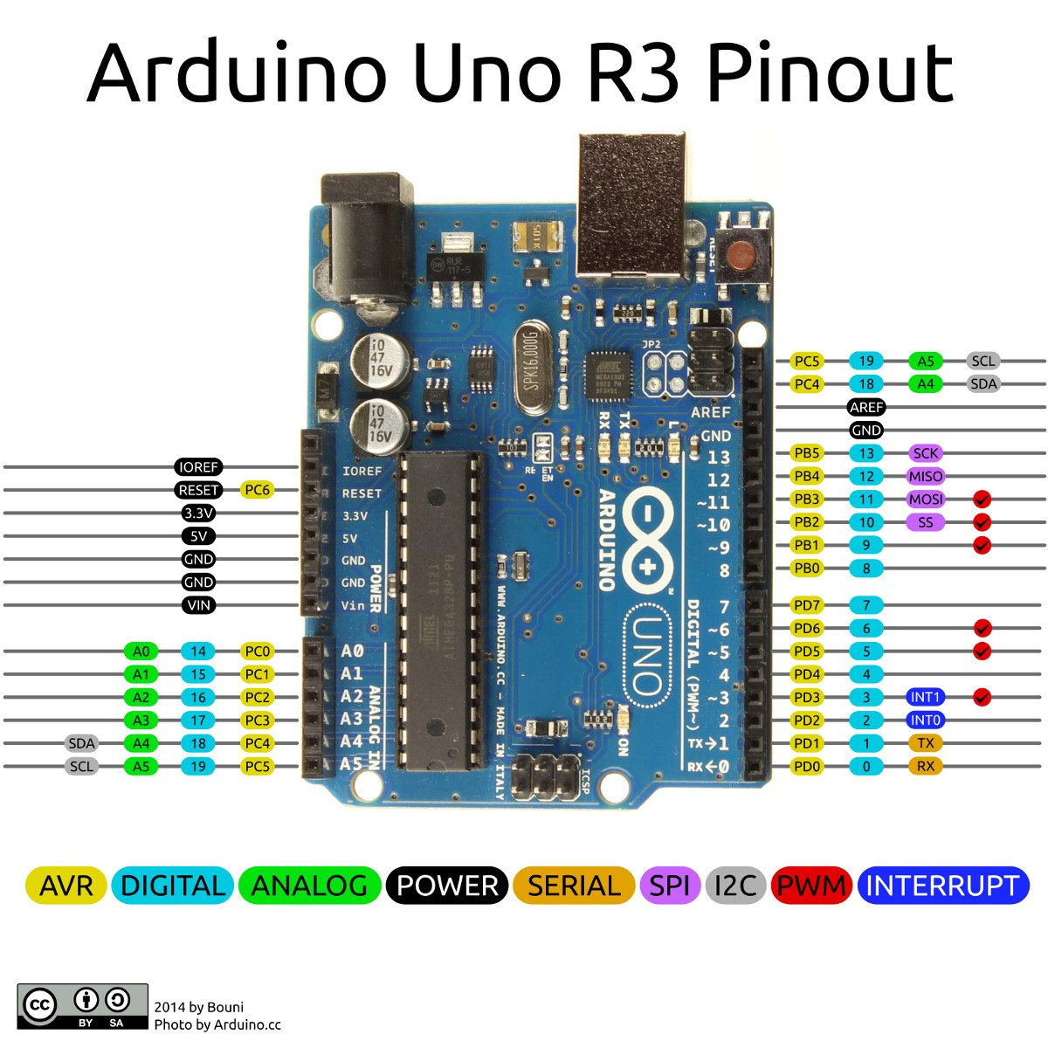The **Arduino Uno** is an [open-source](https://en.wikipedia.org/wiki/Open-source) [microcontroller board](https://en.wikipedia.org/wiki/Microcontroller_board)  based on the [Microchip](https://en.wikipedia.org/wiki/Microchip_Technology) [ATmega328P](https://en.wikipedia.org/wiki/ATmega328P) microcontroller and developed by [Arduino.cc](https://en.wikipedia.org/wiki/Arduino). The board is equipped with sets of digital and analog [input/output](https://en.wikipedia.org/wiki/Input/output) (I/O) pins that may be interfaced to various [expansion boards](https://en.wikipedia.org/wiki/Expansion_board) (shields) and other circuits. The board has 14 digital I/O pins (six capable of [PWM](https://en.wikipedia.org/wiki/Pulse-width_modulation) output), 6 analog I/O pins, and is programmable with the [Arduino IDE](https://en.wikipedia.org/wiki/Arduino#Software) (Integrated Development Environment), via a type B [USB cable](https://en.wikipedia.org/wiki/USB_cable). It can be powered by the USB cable or by an external [9-volt battery](https://en.wikipedia.org/wiki/9-volt_battery), though it accepts voltages between 7 and 20 volts.

**Fig 5: ARDUINO UNO**

**GSM MODULE**

The [Arduino GSM shield](https://docs.arduino.cc/en/Main/ArduinoGSMShield) allows an Arduino board to connect to the internet, send and receive SMS, and make voice calls using the library. The shield will work with the Arduino Uno out of the box. The shield will work with the Mega, Mega ADK, Yun, and Leonardo boards with [a minor modification](https://docs.arduino.cc/en/Guide/GSMShieldLeonardoMega). The Due is not supported at this time. The [GSM library](https://docs.arduino.cc/en/Reference/GSM) is included with [Arduino IDE 1.0.4 and later](https://docs.arduino.cc/en/Main/Software).

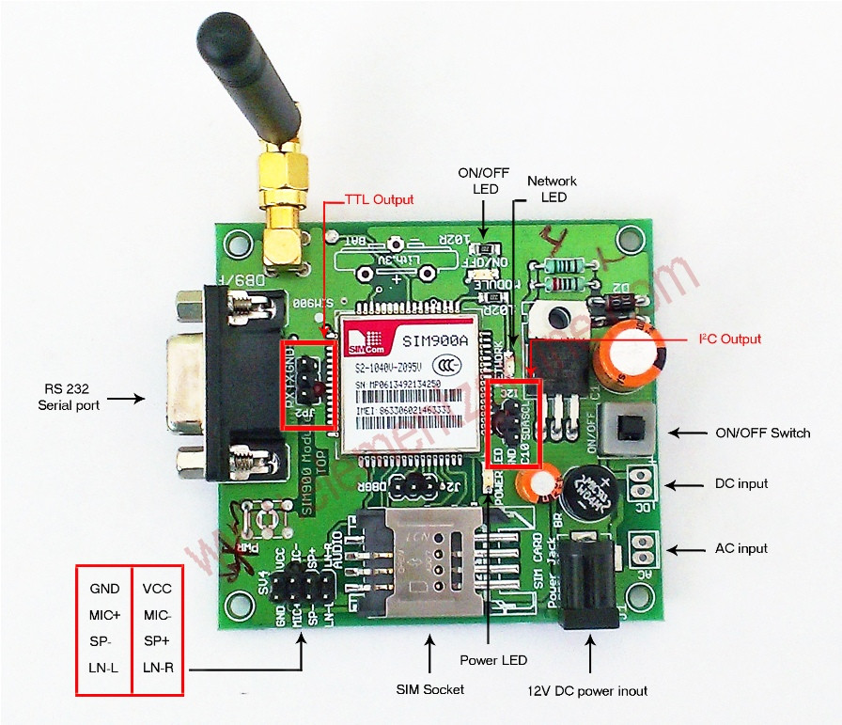GSM is an international standard for mobile telephones. It is an acronym that stands for Global System for Mobile Communications.

**Fig 6: GSM Module**

It is also sometimes referred to as 2G, as it is a second-generation cellular network.

To use GPRS for internet access, and for the Arduino to request or serve webpages, you need to obtain the Access Point Name (APN) and a username/password from the network operator.

See the information in Connecting to the Internet for more information about using the data capabilities of the shield. Among other things, GSM supports outgoing and incoming voice calls, Simple Message System (SMS or text messaging), and data communication (via GPRS).The Arduino GSM shield is a a GSM modem. From the mobile operator perspective, the Arduino GSM shield looks just like a mobile phone. From the Arduino perspective, the Arduino GSM shield looks just like a modem.

**STEP-UP TRANSFORMER**

A **step-up transformer** is a type of transformer that converts the low voltage (LV) and high current from the primary side of the transformer to the high voltage (HV) and low current value on the secondary side of the transformer. The reverse of this is known as a step-down transformer.

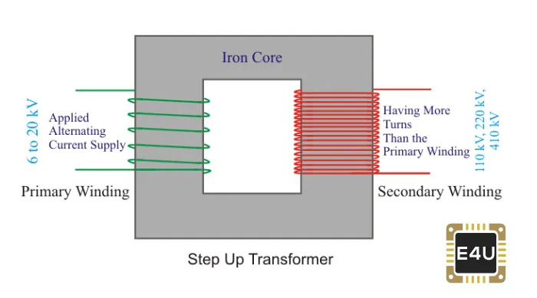A transformer is a piece of static electrical equipment which transforms electrical energy (from primary side windings) to the magnetic energy (in the transformer’s magnetic core) and again to the electrical energy (on the secondary transformer side). A step-up transformer has a wide variety of applications in electrical systems and transmission lines.

**Fig 7: Step Up Transformer**

1. **FLOW CHART**

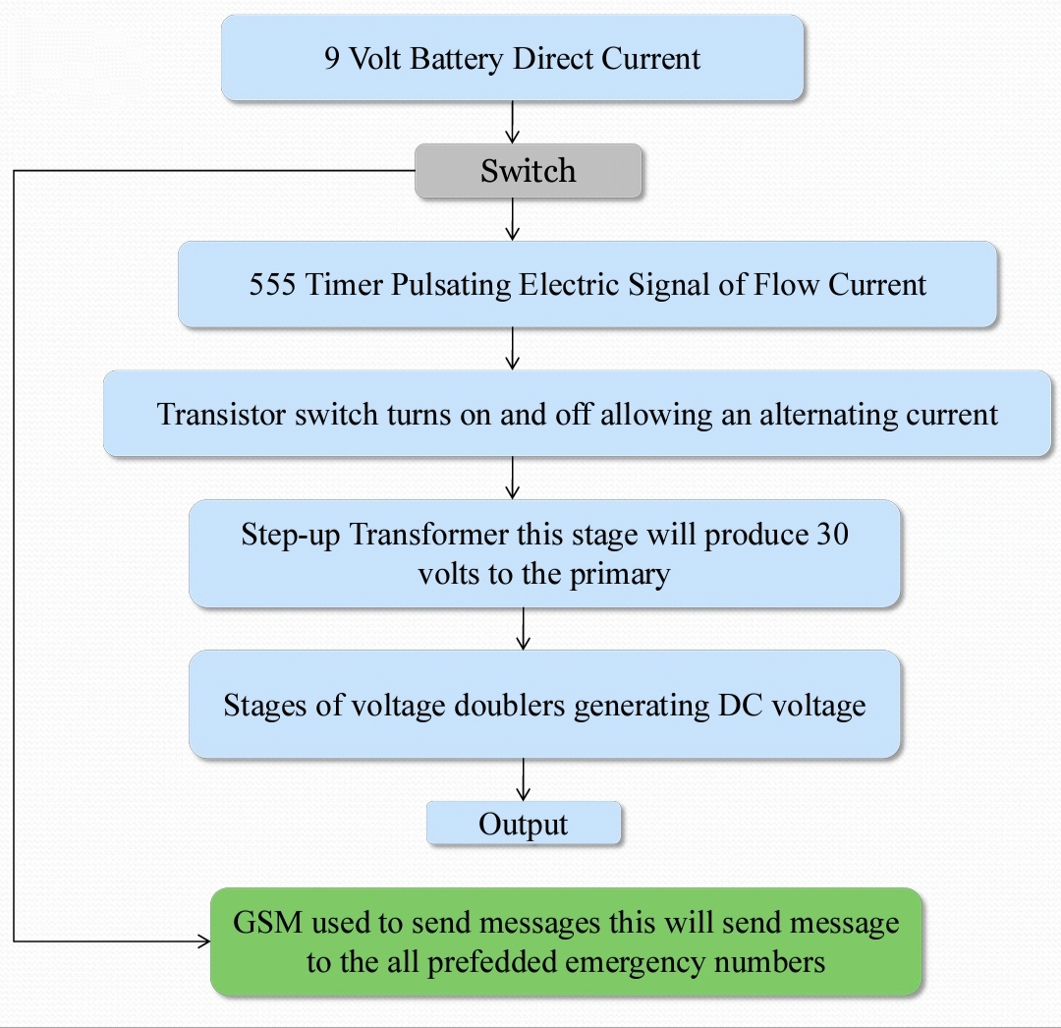

1. **CIRCUIT DIAGRAM**

**Fig 8: Circuit Diagram in MULTISIM**

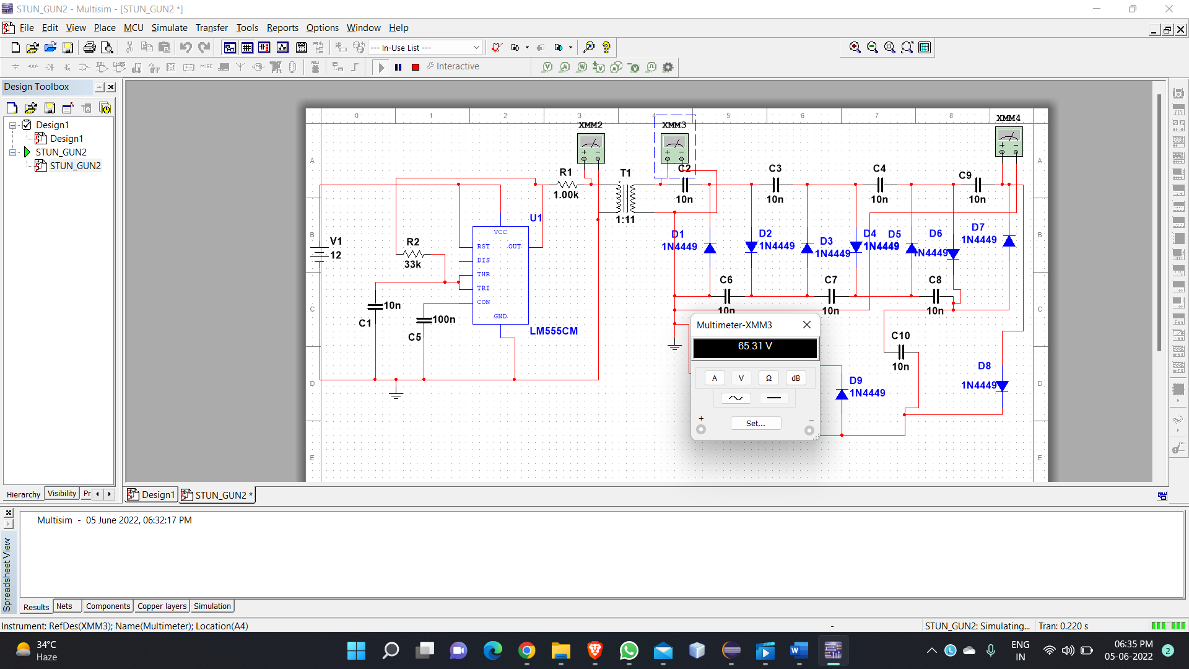

**Fig 9: Circuit Diagram in MULTISIM with Transformer Voltage Output**



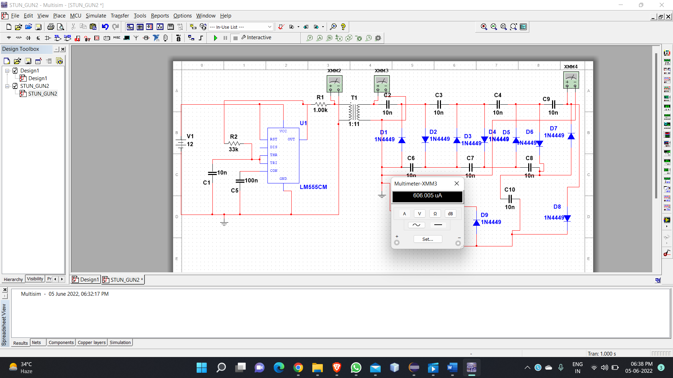

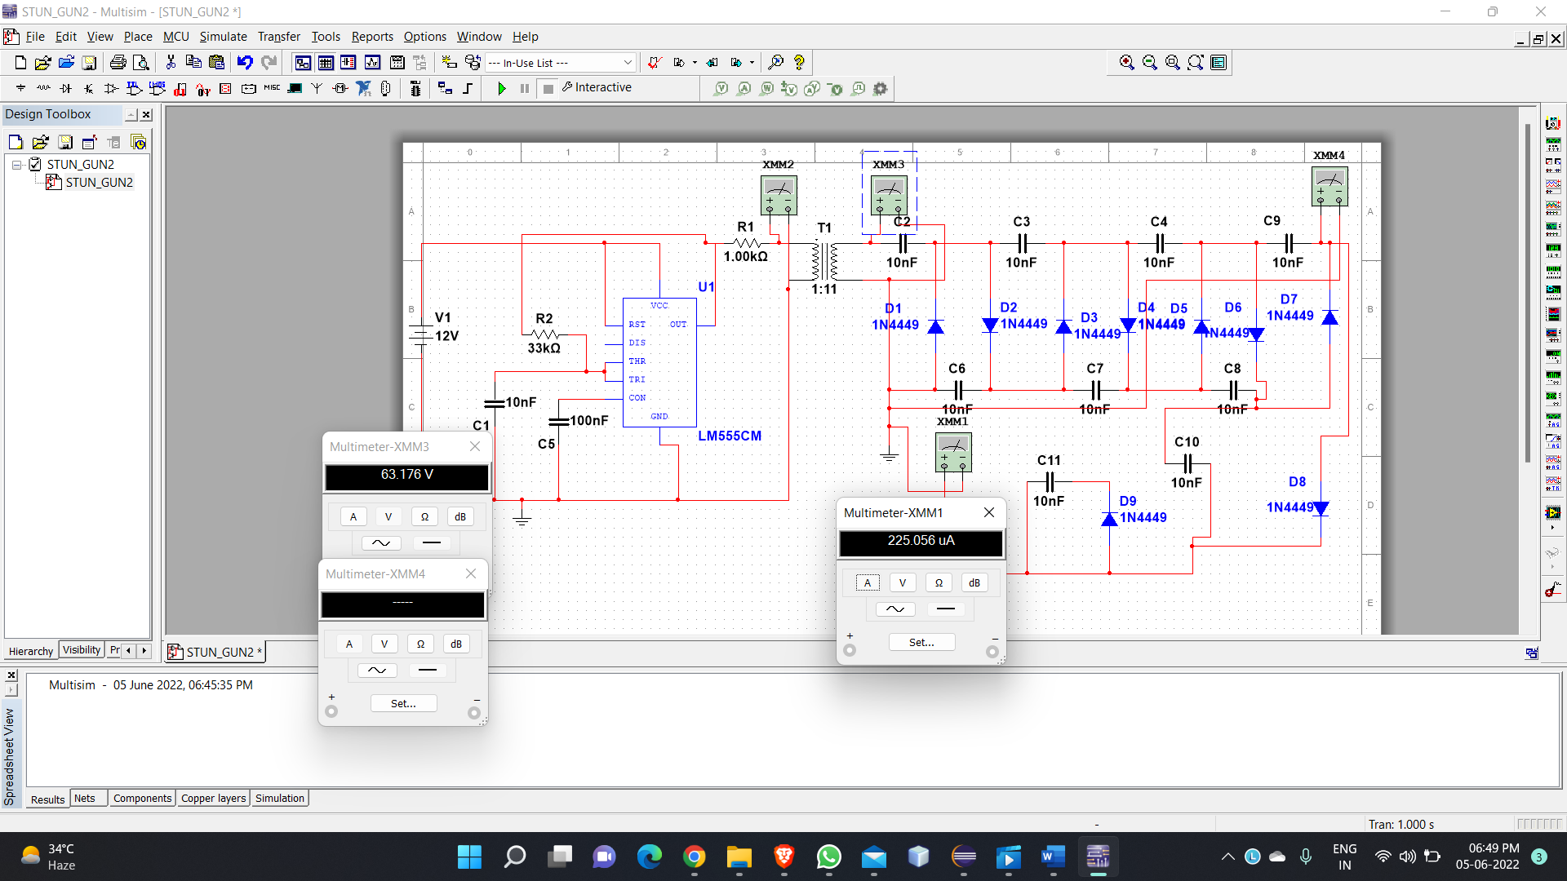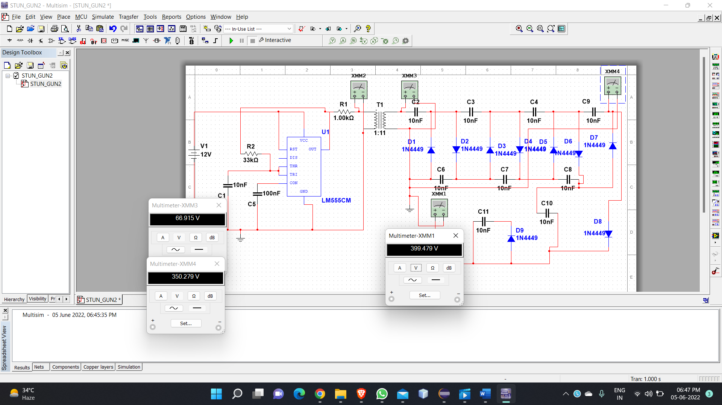

**Fig 10: Circuit Diagram in MULTISIM with Transformer Current Output and Total Circuit’s Voltage and Current Output**

**6. HARDWARE IMPLEMENTATION**

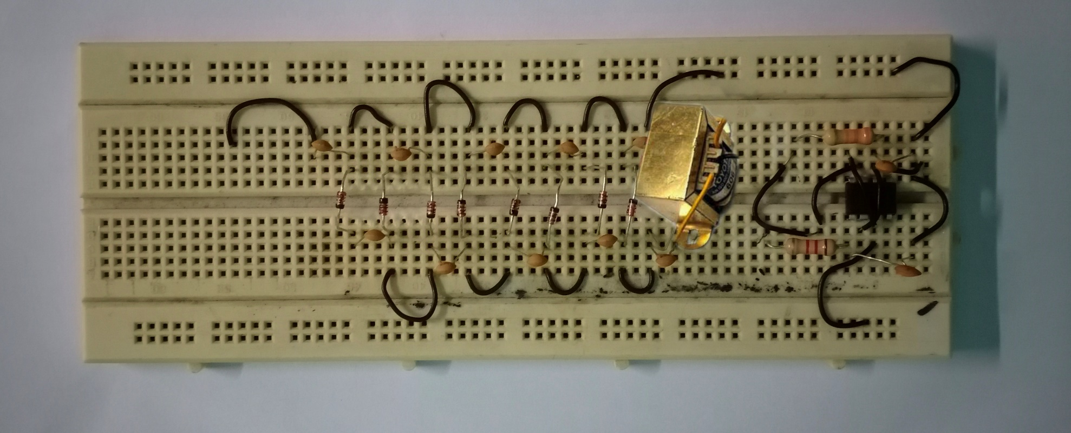

**Fig 11: Stun Gun Circuit used for Generating High Voltage and Low Current**



**Fig 12: Arduino Uno and Gsm 900A for Sending Emergency Message**

**7. CIRCUIT DESCRIPTION**

A stun gun is a gadget used to produce a high voltage, low current signal, used mostly as a weapon to stun or send shock waves to the target with the intention to weaken or paralyze it. However, proceeding to design the circuit, it should be kept in mind that in some countries, stun gun is banned. Because, this is actually a lethal weapon which can render a person mentally paralyzed. It is usually powered by a 9V battery.

Here, we design a stun gun circuit using a 555 Timer to produce a current fluctuating signal and a voltage multiplier using a transformer and a multiple stage arrangement of voltage doublers using capacitors and diodes.

The stun gun circuit is based on the principle behind a conventional stun gun. A 555 Timer is used to produce an oscillating signal of frequency determined by the external passive elements connected to the Timer. These low current electric pulses are fed to a step-up transformer to produce a high volt signal, which is further increased by a voltage multiplier circuit.

The voltage multiplier circuit consists of multiple stages of voltage doubler each consisting of two diodes and two capacitors.

The voltage doubler circuits are based on Villard doubler method. Output voltage is directly proportional to the number of stages.

As soon as the switch S1 is pressed, the astable operation of 555 Timer starts. A pulsating electric signal of low current is produced, which is stepped up using a step-up transformer, to a voltage of around 1000V. The signal from the Timer is fed through a MOSFET switch.

1. During first positive half cycle, capacitor C3 charges through diode D1, which is forward biased. Since the capacitor has no discharge path, it stores the charge. This produces a voltage equal to the AC input peak value at the end of half cycle.
2. During negative half cycle, diode D2 is forward biased and capacitor C4 charges through C3 and D2. At the end of the cycle a voltage equal to double the input AC voltage.
3. Again, during next positive half cycle, diode D3 is forward biased and capacitor C5 charges. Again during next half cycle, diode D4 is forward biased and capacitor C6 charges. At the end of the cycle, a voltage equal to 4 times the input peak voltage is obtained at point 2.
4. The same procedure applies for other two stages and finally a voltage equal to 10 times the input voltage is obtained at point 5.

**8. RESULT**

**Stun Gun Applications:**

1. It can be used for security purpose for individuals from intruders.
2. It can be used as protection from animals.
3. It can be used as modern warfare equipment.

**9. LIMITATIONS OF STUN GUN CIRCUIT**

1. Since this involves high voltage pulse production, the circuit is hazardous and should be implemented on hardware with uttermost care and precaution.
2. One should not touch the output with bare hands as this high voltage, low current signal can send shock waves through the body, disrupting the nervous system.
3. While designing the circuit, factors like corona discharge, stray capacitance are not taken into account, which may affect the output.
4. This circuit should never be used in presence of persons with cardiac issues.
5. It is actually to get a 9:1000 step up transformer at low frequency and its construction is quite complex.
6. **CONCLUSION**

Here, we have come to the end of the project on women safety device using GSM sos message system. I tried my best to include all the necessary points that are required related to the given topic. This report contains information of our project thoroughly. We do hope that our project will be useful and may be effective.

This report has discussed the development of a Woman safety instrument. The objectives of this lab were to develop the necessary hardware and software projects to enhance our knowledge and developing progressive ideas.

Our topic was women safety device which is a Taser with gsm-sos message alert system. Although various technology is present for woman safety none often real time defense and alert message transmission simultaneously. Be it a Taser or a stun gun there is a 15% chance that it may not immobile the assaulter, but the SOS message is successfully sent. Thus, a product using existing microcontroller technology incorporated with the GSM connectivity would enhance the utilities of these devices as a must have for women

1. **FUTURE WORK**

We aim to work on the shape and size of the stun gun so that it can be carried anywhere. The 75% duty cycle and low frequency seem very wasteful in this project since the MOSFET can easily handle the higher frequencies and the capacitors will have a lower impedance at such frequencies allowing a greater output current. If the low frequency was chosen because of an iron core transformer, it should be replaced with a ferrite core, because it is: more efficient, can handle higher frequencies, is lighter, and more compact for a stun gun. Finally, the transformer does not respond more strongly to a longer duty cycle after a point, so there is definitely wasted input there also.

**12. REFERENCE**

1. “Basic circuit Analysis” by k.v.vmurthy.

2. Digital circuit /Digital Integrated Budronies “by H.Taub D .schilling.

3. “Transduces &instrumentation” (sensory by D.V.S mothy,

4. Sinclair Ian R. and Dunton John, Practical Electronic Handbook, 6th Edition, 2007. 3. Horton Ivor,

Beginning C, Wrox Press Ltd, Birmingham, U.K, 2nd Edition, 2002

5. Brown Forrest John, Embedded Systems Programming in C and Assembly, Van Nostrand Reinhold,

N.Y, Prentice-Hall, 2003.

6. Deshmukh V Ajay, Microcontrollers Theory and Applications, New Delhi, Tata McGraw-Hill

Publishing Co. Ltd, 2005.